**UML Assignments:**

1. Airline Reservation System:

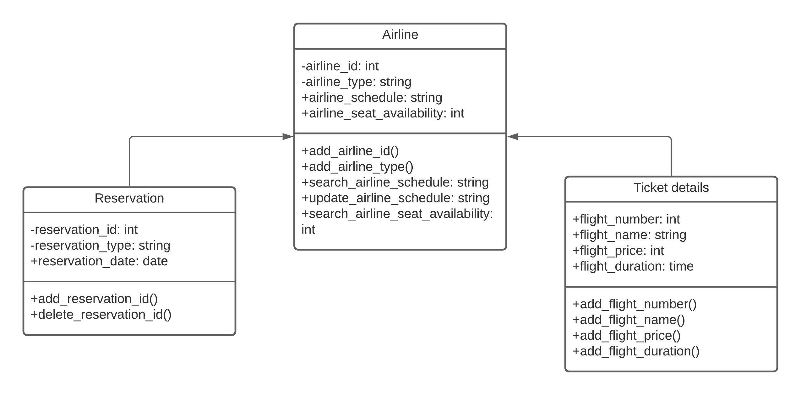

1. Design and draw uml class diagram with attributes, behaviour, and class relationships for the following scenario.

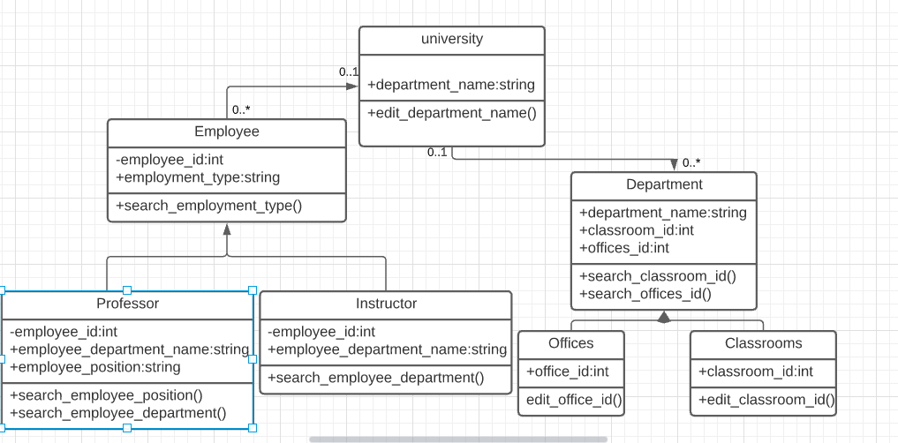

1. Draw an activity diagram for the given scenario where a student needs to enrol with the university for the given course.

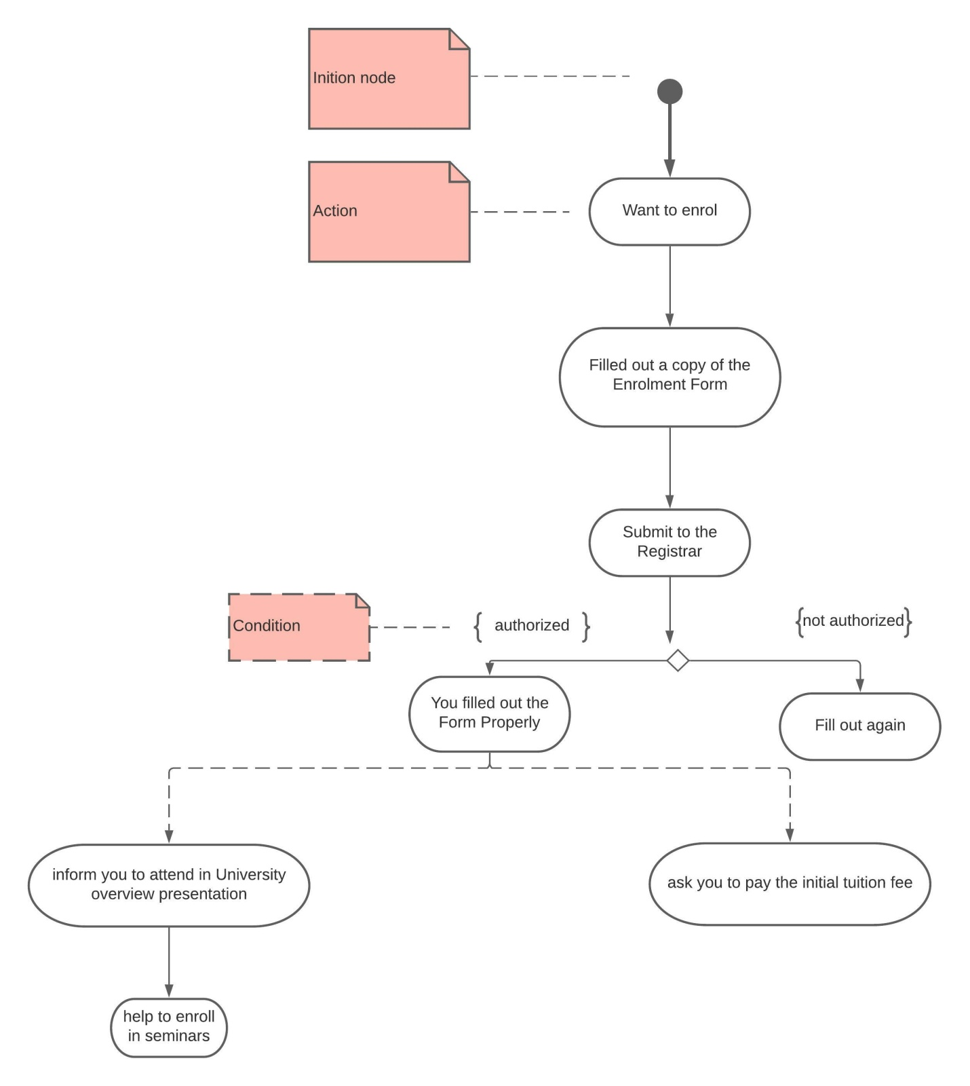

1. A scenario of online library management system is given below. you need to refer the use case diagram and moving further need to create a sequence diagram for the same.

